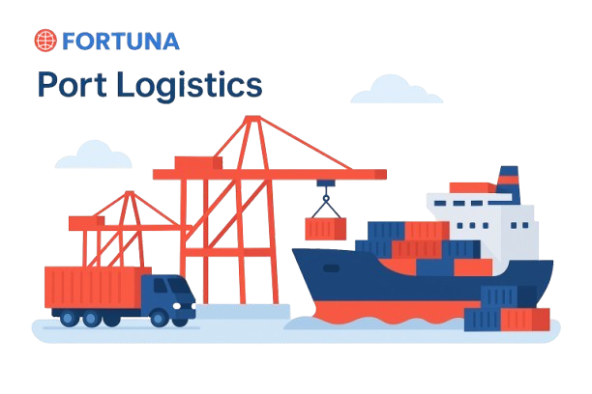



Website: www.fortunaglobalsupplychain.com
E-mail: info@fortunaglobalsupplychain.com

🏢 Company Overview

Fortuna Global Supply Chain Systems is a next-generation enterprise technology company revolutionizing the global logistics and supply chain landscape.
With a vision to create intelligent, transparent, and connected ecosystems, Fortuna blends innovation, data intelligence, and automation to help businesses achieve supply chain excellence.
Established with the belief that efficiency is the new currency, Fortuna empowers organizations to manage operations smarter — from demand planning to last-mile delivery — through real-time insights and seamless digital integration.
We are not just a technology provider; we are partners in transformation — driving global supply chain optimization with precision, performance, and predictive intelligence.

FORTUNA GLOBAL SUPPLY CHAIN SYSTEMS

“The Future of Enterprise Intelligence.”

Fortuna Last Mile AI – “AI-driven Last-Mile Route & Risk Optimization Platform”

Fortuna Last-Mile is an advanced, AI-driven Route & Risk Optimization Platform designed to ensure precision, efficiency, and intelligence in the final leg of logistics operations. Built as part of the Fortuna Global Supply Chain Systems Suite, it leverages machine learning, predictive analytics, and real-time visibility to streamline last-mile deliveries, minimize costs, and enhance customer satisfaction. The platform seamlessly integrates with transportation management, warehouse operations, and demand planning systems — ensuring complete alignment between planning and execution. 
The purpose of Fortuna Last Mile AI is to transform last-mile delivery challenges into opportunities through intelligent orchestration, dynamic routing, and proactive risk management.
Our vision is to empower enterprises with predictive, data-driven delivery intelligence that ensures every mile is optimized for time, cost, and sustainability — paving the way for the future of autonomous and intelligent last-mile ecosystems.

⚙️ 2. System Architecture
Fortuna Last Mile AI is a cloud-native, modular SaaS ecosystem that connects planning, real-time tracking, and risk intelligence into one cohesive digital layer.
Key Layers :
- Data Integration Layer – Aggregates data from TMS, WMS, ERP, and IoT devices.
- AI Core Engine – Performs predictive analytics, route optimization, and anomaly detection.
- Real-Time Visibility Layer – Provides live shipment status, ETA predictions, and geofencing.
- Risk & Exception Management Layer – Detects, analyzes, and mitigates operational disruptions.
- User Interface Layer – Interactive dashboards and mobile apps for drivers, dispatchers, and managers.
- API & Integration Layer – Enables seamless connectivity with third-party logistics and ERP systems.

⚙️ 2. System Architecture Diagram
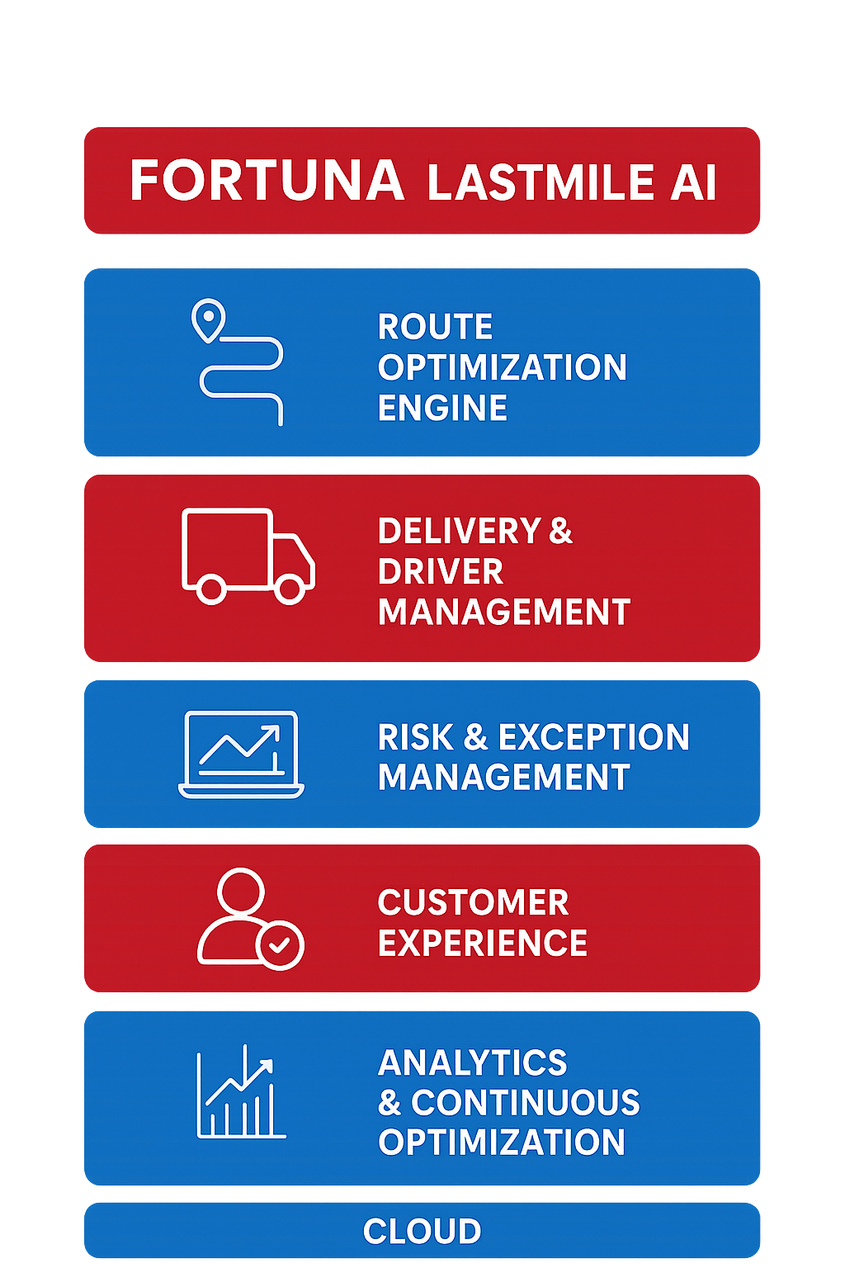

📍 1: Route Optimization & AI Planning

Product Modules, Sub-Modules & Operational Functionality

📚 Submodules:
- Dynamic Route Planner: Auto-creates best delivery paths using live order and location data.
- AI Traffic Predictor: Anticipates traffic congestion and adjusts routes dynamically.
- Multi-Drop & Load Consolidator: Groups deliveries intelligently to optimize resource usage.
- Carbon Impact Analyzer: Suggests eco-friendly routes with minimal emissions.

⚙️ Operational Functionality:
- Leverages AI algorithms to generate optimal delivery routes minimizing time and fuel costs.
- Dynamically re-routes deliveries based on live traffic, weather, and delivery constraints.
- Considers load balancing, vehicle type, and priority levels in route computation.
- Continuously learns from historical data to improve future routing precision.

Product Modules, Sub-Modules & Operational Functionality

📚 Submodules:
- Historical Data Modelling – Learns from past sales, promotions, and seasonal behaviour.
- AI Forecast Generator – Produces short-term, mid-term, and long-term forecasts.
- External Signal Integration – Considers weather, events, and market indexes.
- Forecast Accuracy Tracker – Monitors prediction reliability using MAPE & RMSE.

⚙️ Operational Functionality:
- Automatically collects and cleans data from ERP/POS systems.
- Generates rolling forecasts updated daily or weekly.
- Uses deep learning algorithms to detect new demand trends.
- Provides scenario simulations (“what-if” analysis).

👨‍ 2: Delivery & Driver Management

📚 Submodules:
- Driver Assignment Optimizer: Allocates the best-suited driver for each route.
- Smart Dispatch Console: Automates dispatch workflows with live route insights.
- ePOD (Electronic Proof of Delivery): Digitally captures customer confirmation with geo-tagging.
- Driver Performance Analytics: Evaluates driver efficiency and safety KPIs.

⚙️ Operational Functionality:
- Automates driver assignment based on proximity, capacity, and performance metrics.
- Enables real-time communication between dispatchers and delivery personnel.
- Monitors driver performance, route adherence, and delivery efficiency via analytics.
- Supports digital proof of delivery (ePOD) and shift-level task scheduling.

⚠️ 3: Risk & Exception Management

📚 Submodules:
- Predictive Risk Engine: Identifies potential delivery delays and disruptions early.
- Exception Control Tower: Monitors ongoing operations and flags high-impact issues.
- Automated Escalation System: Triggers alerts and corrective actions in real time.
- Incident Replay & RCA: Reconstructs incident timelines for precise root-cause analysis.

⚙️ Operational Functionality:
- Detects delivery delays, route deviations, and vehicle breakdowns through AI-driven alerts.
- Automates exception handling workflows with predefined escalation rules.
- Analyzes recurring disruptions to identify high-risk zones or patterns.
- Provides predictive risk scoring to proactively mitigate operational failures.

📍 4: Real-Time Visibility & Tracking

📚 Submodules:
- Live GPS & Telematics Feed: Tracks fleet and driver movement continuously.
- Predictive ETA Engine: Calculates accurate ETAs using ML-driven models.
- Geo-Fence & Zone Monitoring: Monitors vehicle movements within defined service areas.
- IoT Condition Sensors: Captures live environmental data for sensitive shipments.

⚙️ Operational Functionality:
- Provides live GPS-based vehicle tracking with dynamic route deviation alerts.
- Enables end-to-end shipment visibility across hubs, routes, and delivery zones.
- Supports geo-fencing, exception alerts, and automatic ETA recalculations.
- Integrates driver telemetry, IoT data, and digital proof-of-delivery (ePOD) for transparency.

💬 5: Customer Experience & Engagement

📚 Submodules:
- Live Tracking Portal: Offers customers a real-time view of deliveries.
- Predictive Notifications: Sends automatic alerts about delivery timing or changes.
- Delivery Preference Manager: Lets customers reschedule or redirect shipments.
- Feedback & NPS Engine: Collects satisfaction data to improve service.

⚙️ Operational Functionality:
- Enables real-time customer notifications for order status, ETA, and delivery updates.
- Provides branded digital tracking links and interactive communication channels.
- Captures post-delivery feedback and sentiment data to measure service quality.
- Integrates loyalty, satisfaction, and escalation management within one unified interface.

📊 6: Analytics & Performance Optimization

📚 Submodules:
- Operational KPI Dashboard: Displays performance indicators for each delivery region.
- A/B Route Testing Framework: Tests alternative route strategies for efficiency gains.
- Cost & Margin Analyzer: Tracks delivery economics and profitability.
- Predictive Model Retraining: Continuously improves AI models for better accuracy.

⚙️ Operational Functionality:
- Delivers real-time KPIs on delivery efficiency, route performance, and driver productivity.
- Uses AI-driven predictive analytics to identify delivery bottlenecks and optimize outcomes.
- Provides dynamic dashboards and trend visualizations for data-backed decision-making.
- Continuously learns from operational data to enhance model accuracy and forecasting precision.

🔗 7: Integration & API Layer

📚 Submodules:
- ERP / WMS / TMS Connectors: Links internal systems for synchronized data sharing.
- Web hooks & Event Bus: Enables real-time event triggers between systems.
- Developer SDKs: Simplifies integration with custom applications.
- Security & Governance Framework: Enforces encrypted, role-based data access.

⚙️ Operational Functionality:

- Enables seamless data exchange with ERP, TMS, CRM, and third-party logistics systems.
- Supports RESTful APIs and webhooks for real-time status updates and event triggers.
- Facilitates easy onboarding of partner systems through standardized API frameworks.
- Ensures data consistency and integrity with secure authentication and audit trails.

⚙️ 8: Operations & Admin Controls

📚 Submodules:
- Role & Permission Management: Defines user access and system privileges.
- Scenario & Rule Configurator: Allows flexible setup of delivery SLAs and parameters.
- System Monitoring Dashboard: Tracks platform uptime and performance health.
- Audit & Compliance Suite: Maintains operational transparency with full audit logs.

⚙️ Operational Functionality:
- Centralized Command Dashboard
- Dynamic SLA & Policy Configuration
- User Role & Access Management
- Incident & Exception Handling Framework

📈 Functional Workflows

📦 Order Intake → Captures incoming delivery requests from ERP, e-commerce, or CRM systems in real-time.

📍 AI Route Planning → Leverages AI and traffic intelligence to generate the most efficient delivery paths dynamically.

🚚 Driver Assignment → allocates optimal drivers and vehicles based on proximity, load capacity, and performance metrics.

🛰️ Tracking & ePOD → Provides end-to-end shipment visibility through real-time GPS tracking and IoT integration.

💬 Customer Feedback → Engages customers post-delivery with instant feedback and satisfaction surveys.

📈 Analytics & Continuous Learning → Analyzes operational data across routes, drivers, and delivery patterns for performance trends.

Fortuna EAM Advantages
Feature | Business Value
Faster Deliveries | AI routing reduces transit time and idle miles.
Cost Efficiency | Dynamic optimization lowers operational expenses.
Fully Visibility | Real-time monitoring across every route and asset.
Automation Driven | Minimal manual intervention through intelligent workflows.
Data driven Excellence | Continuous AI learning enhances every delivery cycle.

Automotive & Industrial Manufacturing

🏭 Industries Served


FGSCM - supports the automotive sector with advanced logistics planning, vendor coordination, and predictive maintenance scheduling. From global parts movement to plant-level production support, our systems reduce lead times and enhance supply chain agility

Ports & Logistics
•


Fortuna supports the automotive sector with advanced logistics planning, vendor coordination, and predictive maintenance scheduling. From global parts movement to plant-level production support, our systems reduce lead times and enhance supply chain agility

Food & Beverage Distribution
•

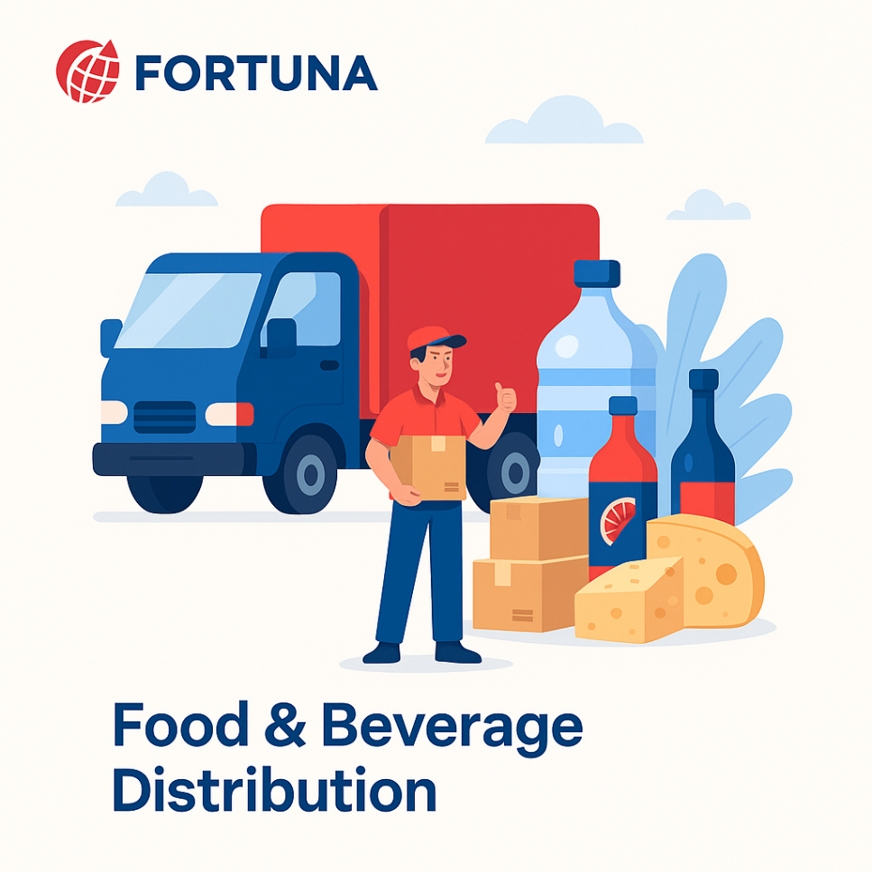
Freshness and safety are at the heart of Food & Beverage -supply chains. We enable end-to-end visibility with IoT-driven tracking, automated quality checks, and predictive demand planning—ensuring traceability from farm to fork.

Fashion & Retail Industry
•


With High seasonal demand & agile supply chain Planning, Fortuna will empowers retailers with faster replenishment & reduces stock outs

Pharma & Healthcare
•


Medical safety and regulatory compliance are non-negotiable. We provide automated solutions for cold chain logistics, product traceability, and compliance monitoring—ensuring life-saving medicines and healthcare products reach destinations safely and efficiently.

E-Commerce & Distributional Channels
•

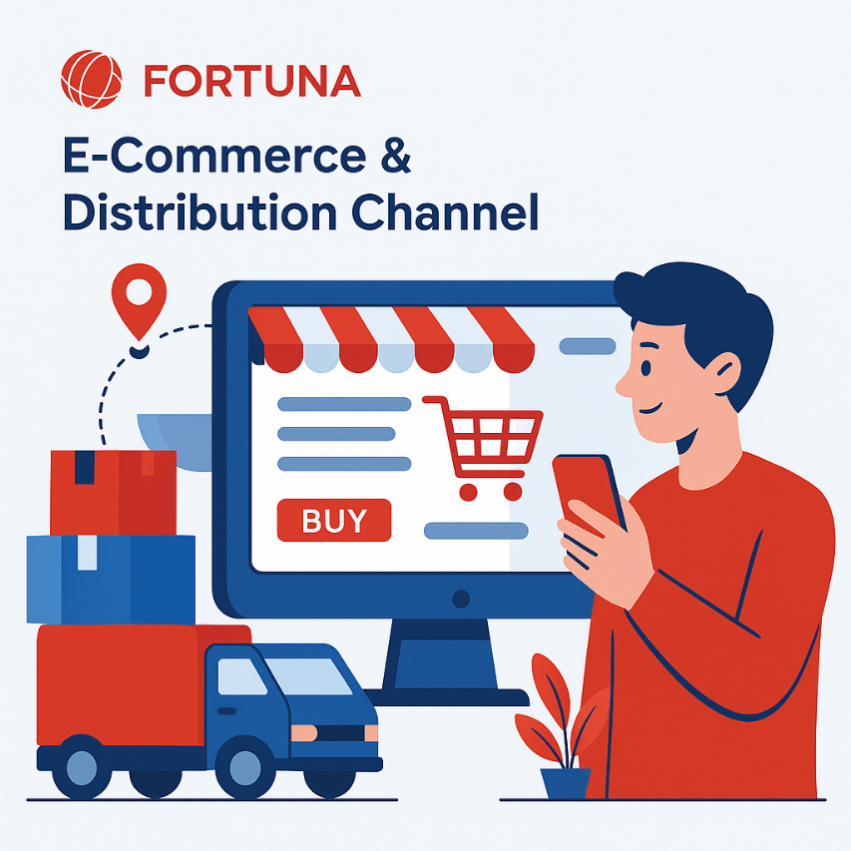
In a fast-moving E-Com world, speed and efficiency are critical. Our platforms enable automated order management, demand forecasting, and last-mile delivery optimization—ensuring customers receive the right products, at the right time, every time.

🏛️ Corporate Identity


Headquarters: Visakhapatnam, Andhra Pradesh, India
Website: www.fortunaglobalsupplychain.com
Email: info@fortunaglobalsupplychain.com

